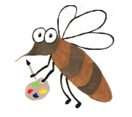

Lyng Primary School Knowledge Organiser

Art

WWI: How to combine paint and texture?

Summer

Year 6

Topic: Art

|  |  |
| --- | --- |
| Vocabulary | |
| **Spelling** | **defintion** |
| abstract | Art that doesn’t necessarily look like it does in real-life. Use shapes, colours and gestural marks |
| analyse | To investigate something in detail to understand it |
| evaluate | To form an opinion about how good or useful something is |
| interpret | To understand and explain the meaning of something |
| medium | The materials use to make a piece of art |
| mixed-media | Art made from a combination of different materials |
| narrative | Is a story recalling events whether fictitious or true |
| respond | To create ideas formed from experiencing art of others |
| tableau | People recreating a scene from a story, painting in a motionless poses |

**Background information for parents and teachers**Learn about the significant artists, architects and designers in history. We will analyse the work of David Hockney, Paula Rego, John Singer Sargent, Fiona Rae and Lubaina Himid. Analysing the historical meaning behind John Singer Sargent’s oil painting ‘Gassed’. Children will focus on the different areas that Sargent was compelled to paint. To recreate artwork and understand the artistic device of the power of juxtaposition between the horror of war and the beautiful game.

|  |
| --- |
| Skills and techniques |
| * Mix textures combining rough and smooth * Create an accurate pattern showing fine detail on the printing plate. * Effectively build up layers of colour. * Use a range of visual elements that reflect the purpose of work. * Sketch |

**Summer**

Gas-attack scene from the trenches

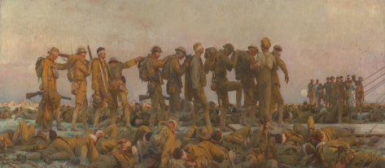



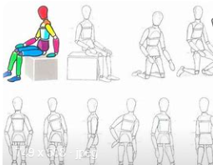

Agreed outcome:

An oil painting replicating a silhouette of human form.